Science Fiction Short Story Builder Template
Use the images below as inspiration from MoPOP’s exhibits and collection to write a short story following the three-act story structure. Stick with one central conflict or main problem in your story that you resolve by the end.
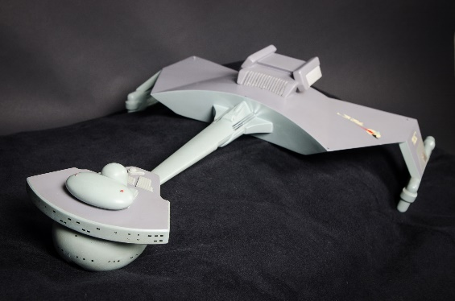 | 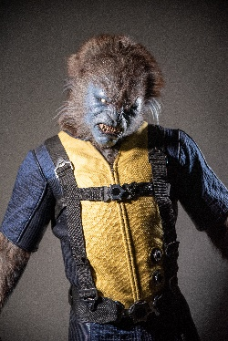 | 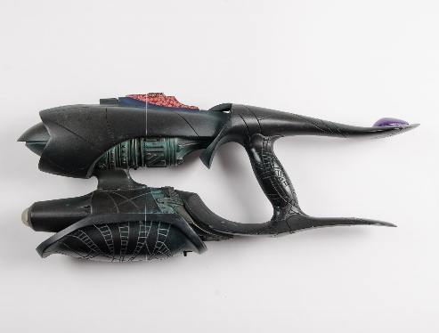
Image 1 | Image 2 | Image 3
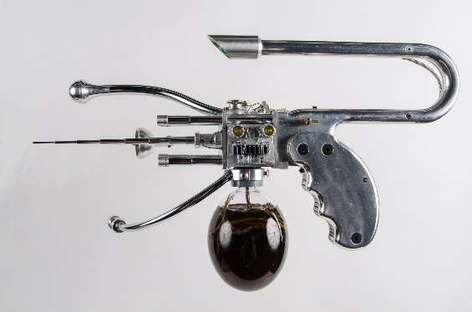 | 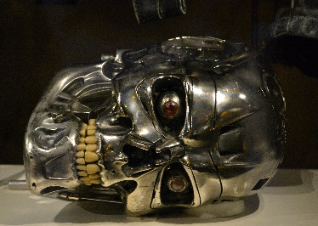 | 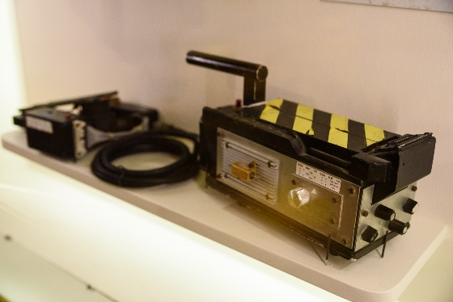
Image 4 | Image 5 | Image 6

Act 1
Pick an image: [drop down menu of image numbers 1-6]
Write a short description of the main character of the story. HINT: Think about who your characters are before your start writing. Know their strengths and flaws.
Who is the main character?: [limit 100 words]

Write a short description of the setting of the story. HINT: Set your story somewhere specific and interesting.
What is the setting?: [limit 100 words]

In act one readers are introduced to the setting, the main character, and the start of the plot line. Don’t forget to use the image you picked as inspiration to start the story.
Write: [limit 1,500 words]

Act 2
Pick a second image: [drop down menu of image numbers 1-6]
In act 2 the plot continues. Develop the characters further and develop the conflict to the point where it looks like all hope is lost! Use the second image you picked as inspiration for act 2 of the story.
Write: [limit 1,500 words]

Act 3
Pick a last image: [drop down menu of image numbers 1—6]
In act 3 the story reaches its climax. Resolve the conflict and bring the story to its resolution. Use the third image you picked as inspiration for act 3 of the story.
Write: [limit 1,500 words]

Author Name:
Email Address:

SUBMIT

Once submitted they will receive a thank you message pop up.
(automatically email to education@mopop.org)

Image Credit
- Image 1 - Klingon D7 battle cruiser filming miniature from the television series Star Trek, 1966 – 1969. Allen Family Collection.
- Image 2 - Beast Costume from the film X-Men: First Class, 2011.
- Image 3 - Illuminating TER (Trans-Phase Eradication Rod) weapon from the television series "Stargate SG-1" 1997-2007. Allen Family Collection.
- Image 4 - Alien Carbonizer pistol from the film "Men in Black" 1997. Allen Family Collection.
- Image 5 - T-800 skull from the film Terminator 2: Judgment Day, 1991. Allen Family Collection.
- Image 6 - Ghost trap with foot-control from the film Ghostbusters, 1984. Allen Family Collection.

